**UCS 2312 Data Structures Lab**

**Assignment 2: ListADT and its application**

Create an ADT for the linked list data structure with the following functions. list*ADT* will have the

integer array and size. [CO1, K3]

1. insert(header,data) – Insert data into the list using inserting at front
2. display(header) – Display the elements of the list
3. insertAtEnd(header,data) – Insert data at the end of the list
4. searchElt(header, key) – return the value if found, otherwise return -1
5. deleteElt(header,data) – Deletes the element data
6. findMiddleElt(header) – find the middle element in the list
7. reverseList(header) – Reverse the list
8. length(header) – find the length of the list

Write an application to use the listADT to do the following:

Test the operations of listADT with the following test cases

|  |  |
| --- | --- |
| **Operation** | **Expected Output** |
| length(header) | 0 |
| insert(header,2) | 2 |
| insert(header,4) | 4, 2 |
| insert(header,6) | 6, 4, 2 |
| insert(header,8) | 8, 6, 4, 2 |
| length(header) | 4 |
| insertLast(header,1) | 8, 6, 4, 2, 1 |
| insertLast(header,3) | 8, 6, 4, 2, 1, 3 |
| length(header) | 6 |
| findMiddleElt(header) | 2 or 4 |
| reverseList(header) | 3, 1, 2, 4, 6, 8 |
| searchElt(4) | 4 |
| searchElt(5) | -1 |
| deleteElt(2) | 8, 6, 4, 1, 3 |

Best practices to be followed:

* Design before coding
* Usage of algorithm notation
* Use of multi-file C program
* Versioning of code

Write a program to add the given two polynomials Example:

Poly1: 6x7+8x3 +7x2+9,

Poly2: 7x3+6

Resultant Poly: 6x7+15x3+7x2+15

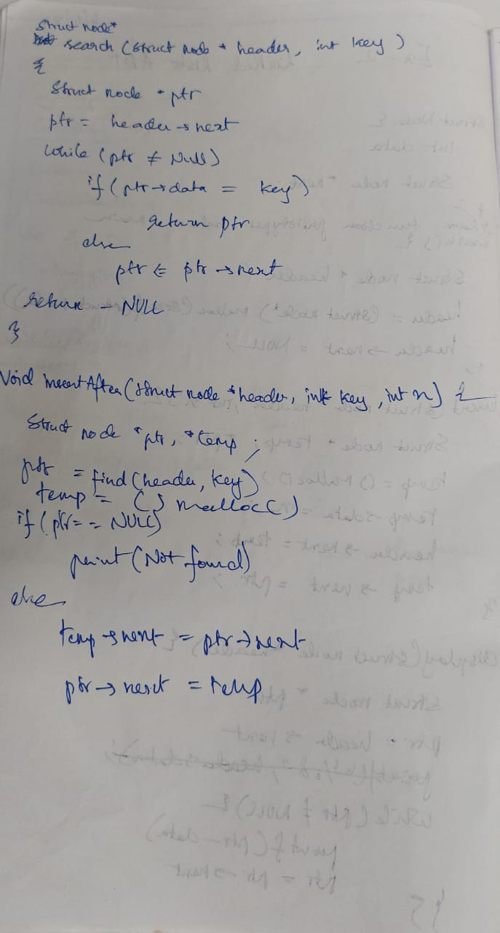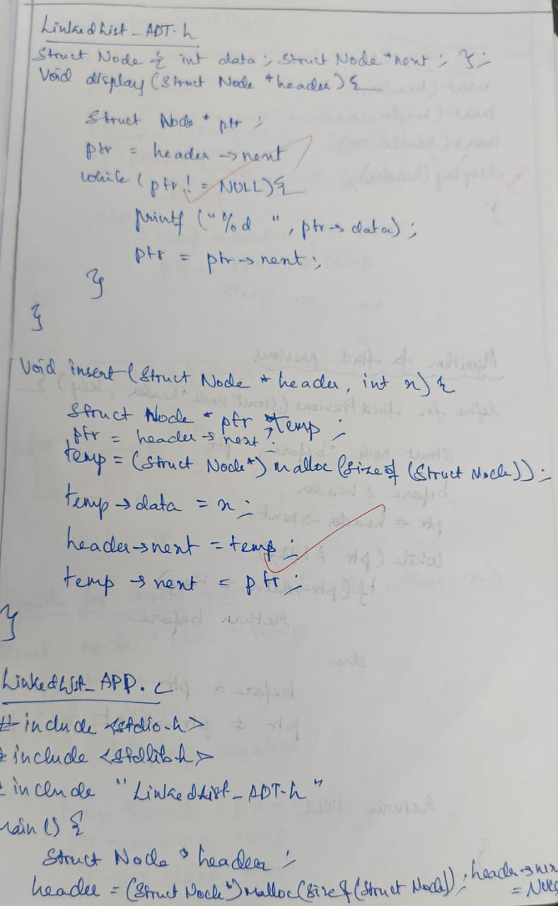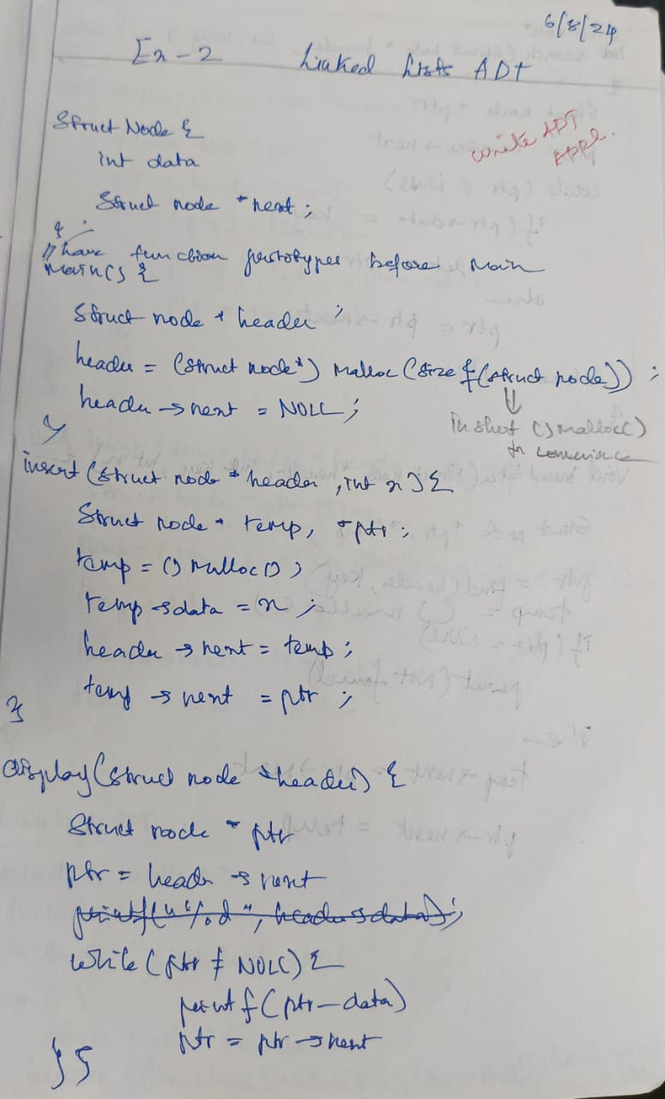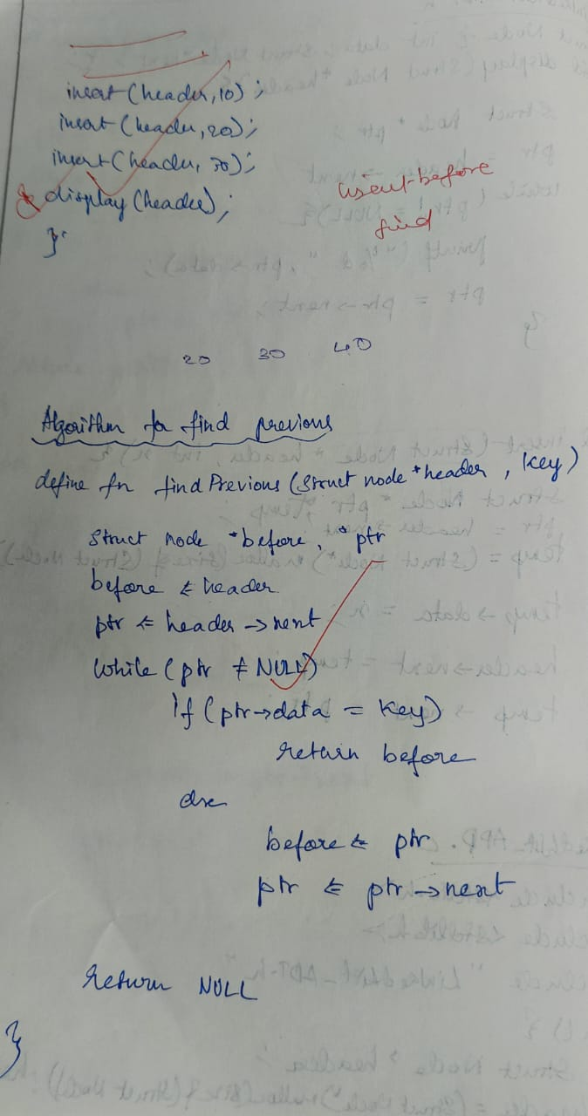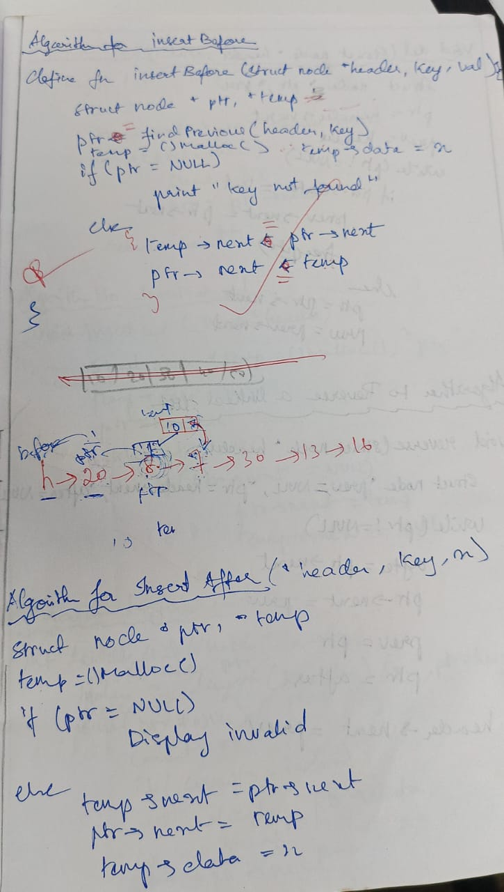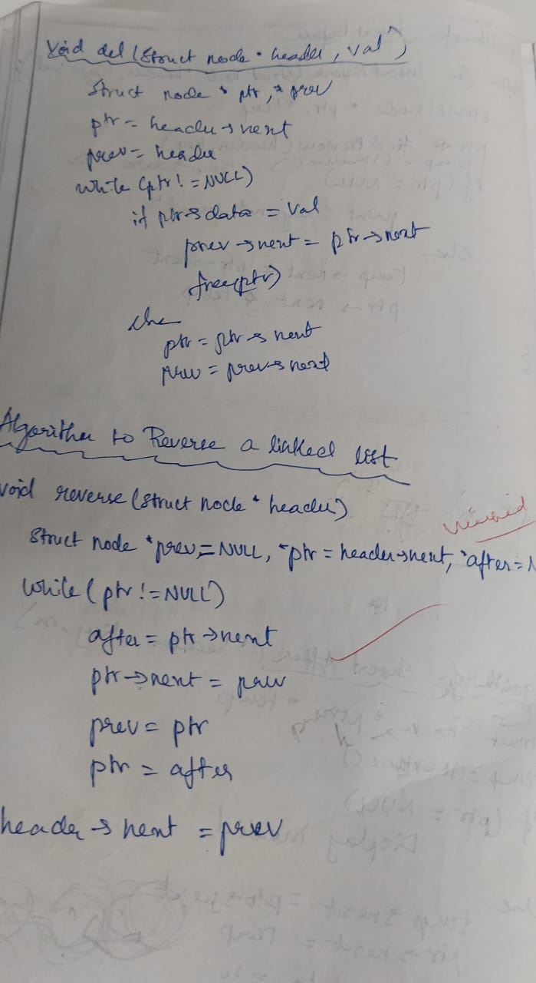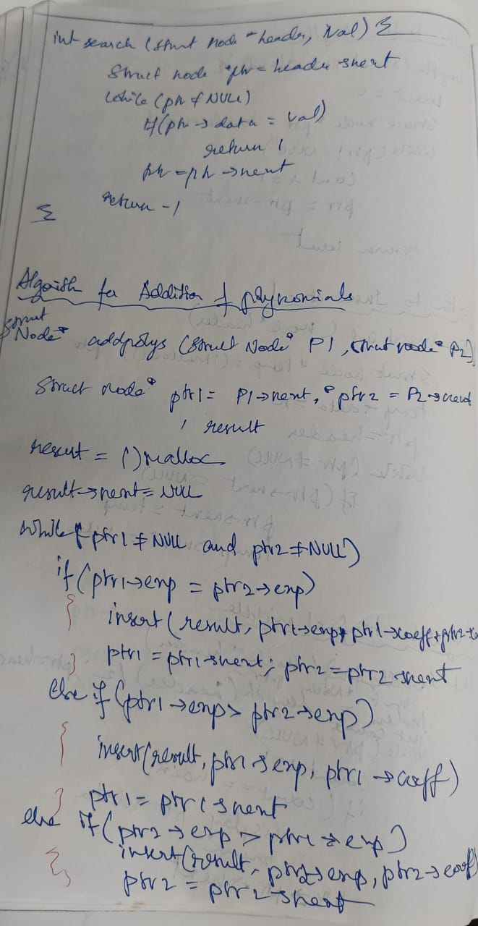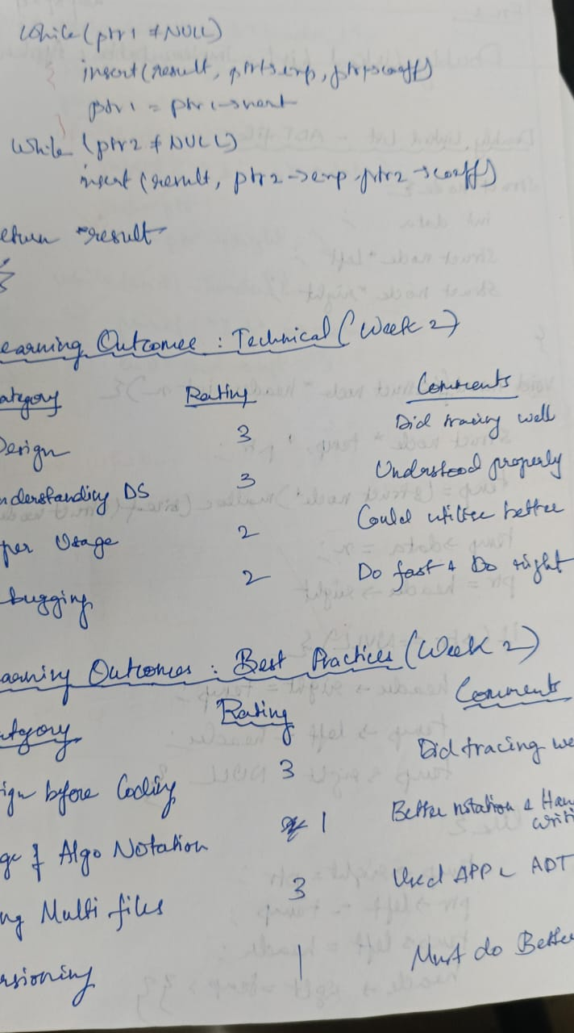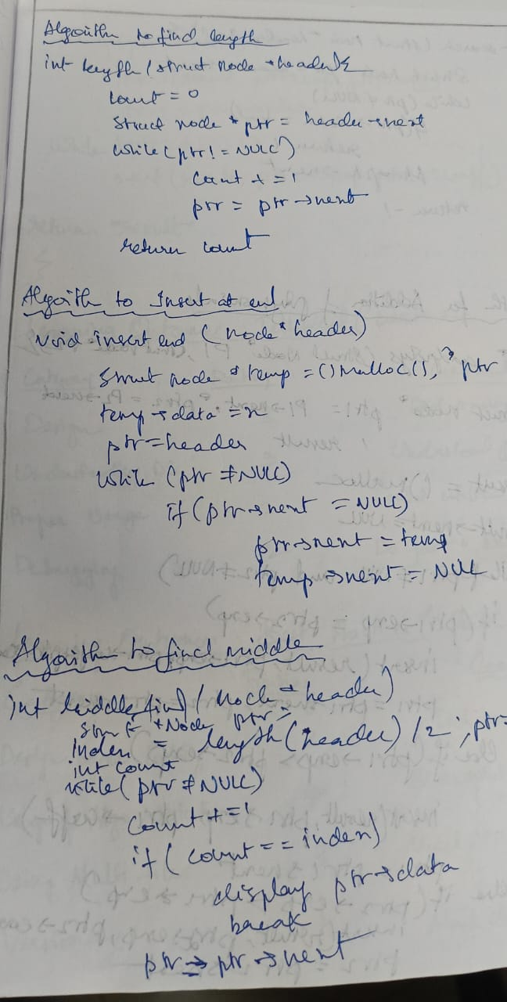

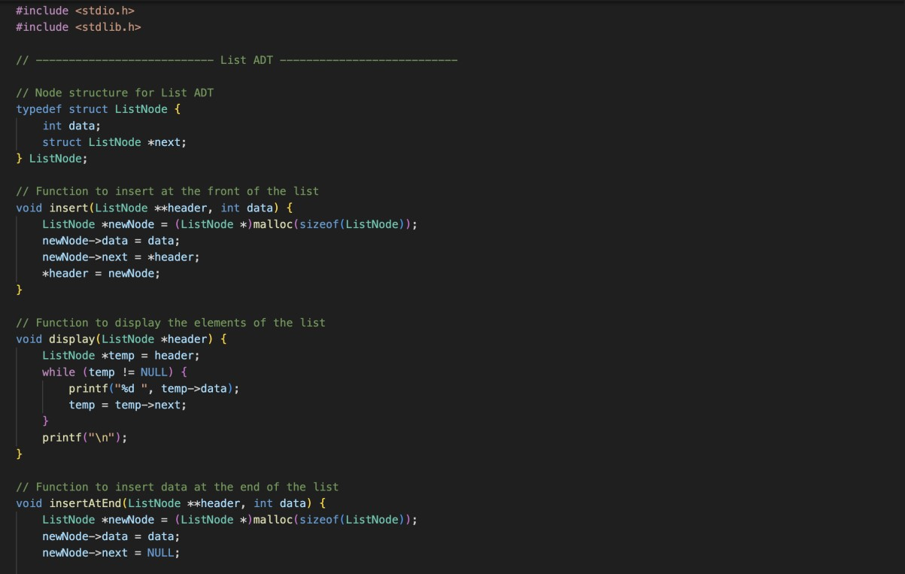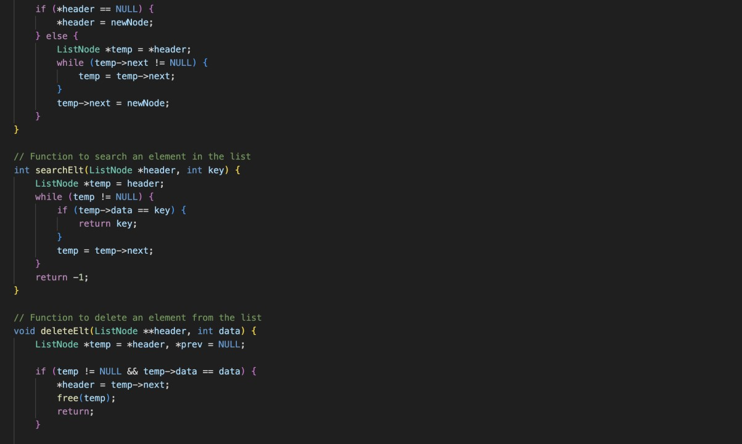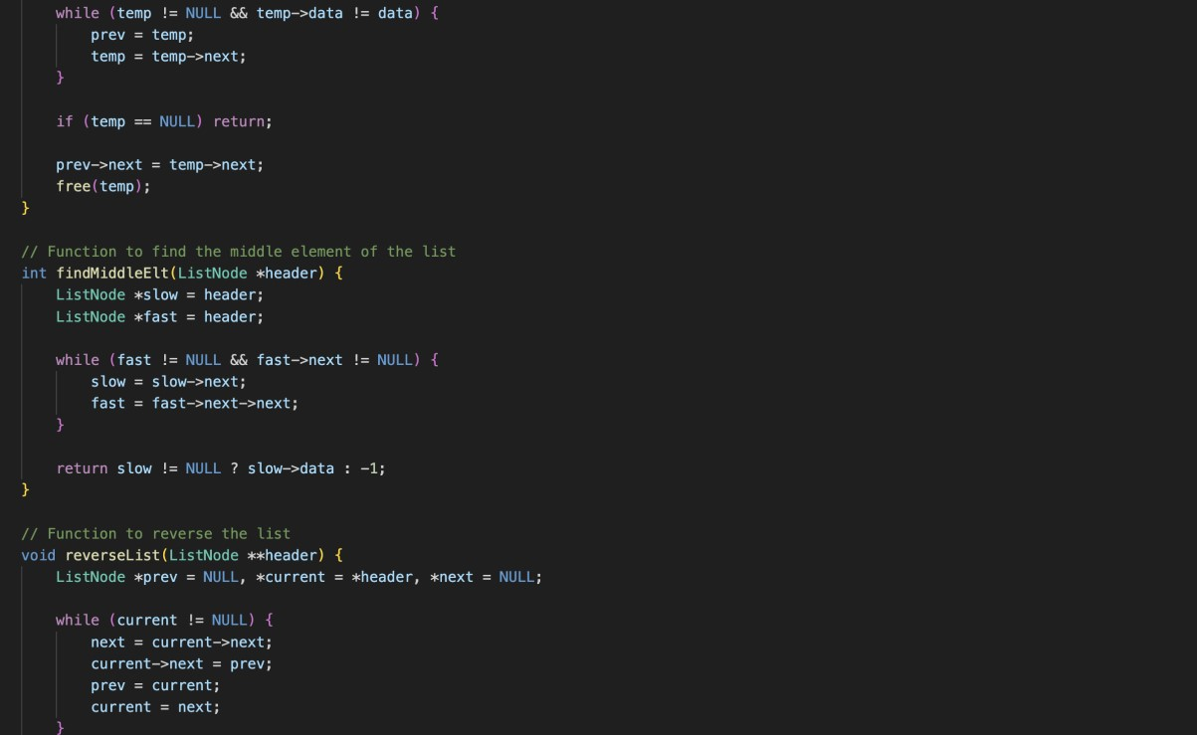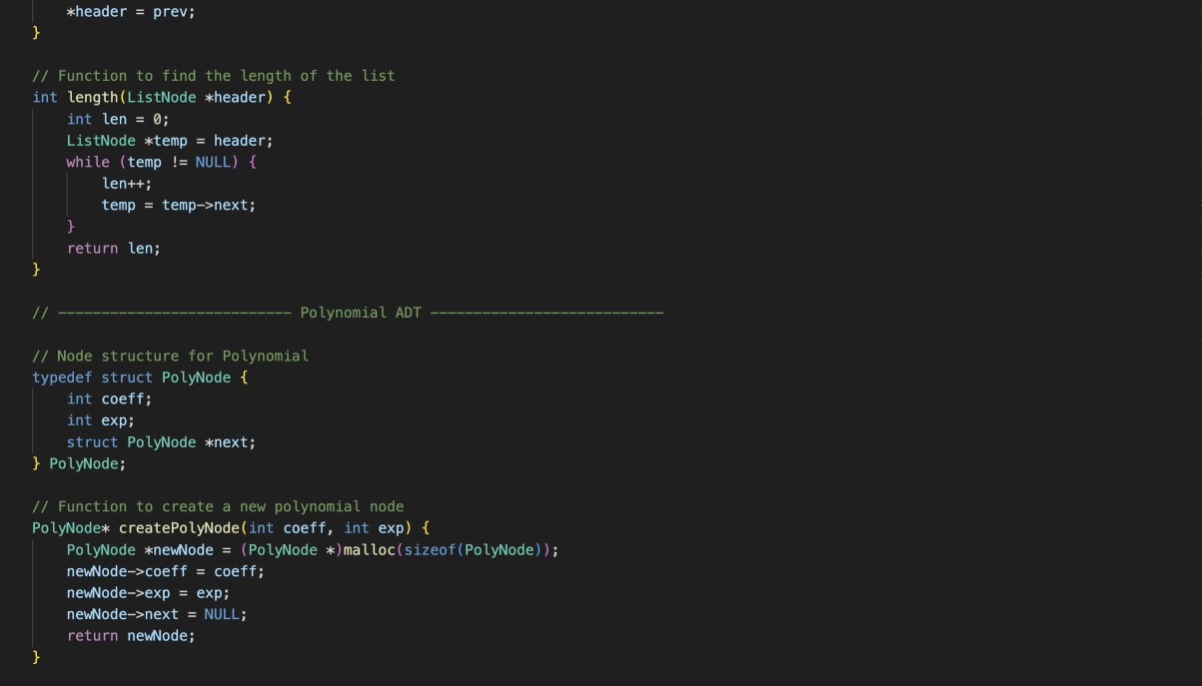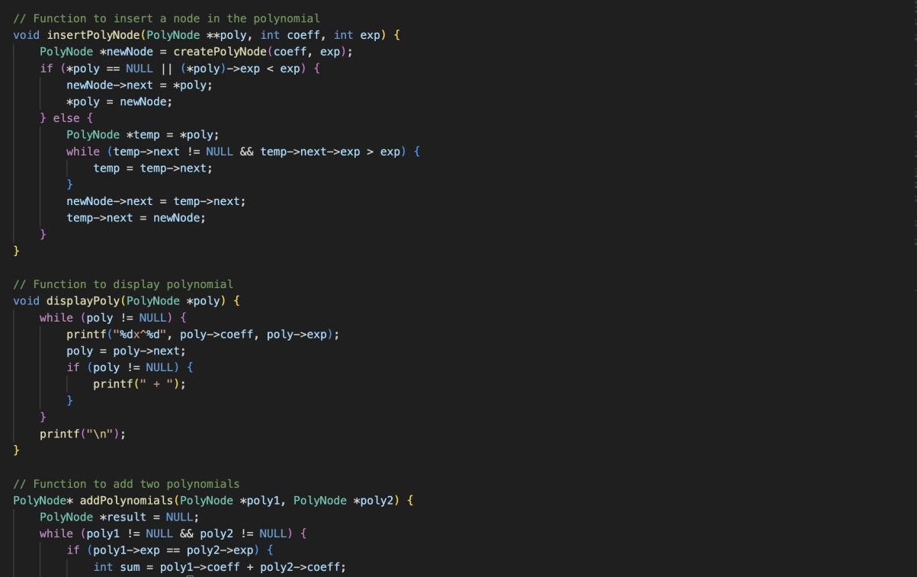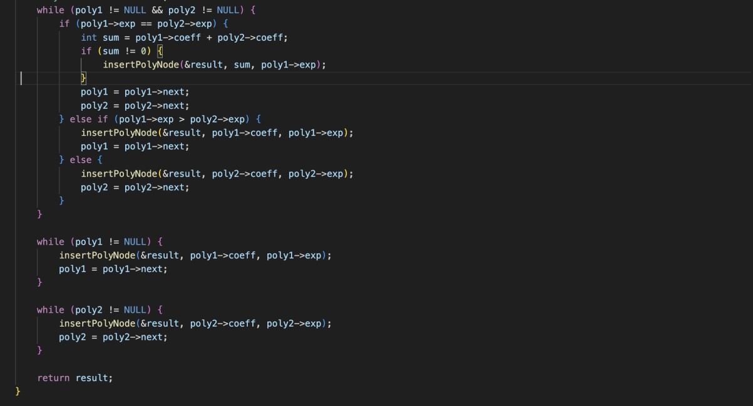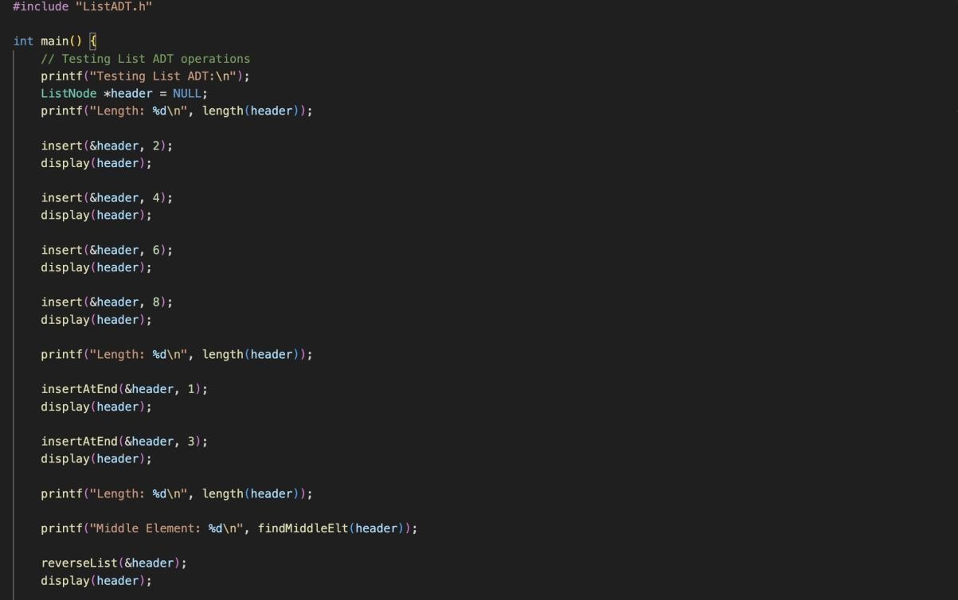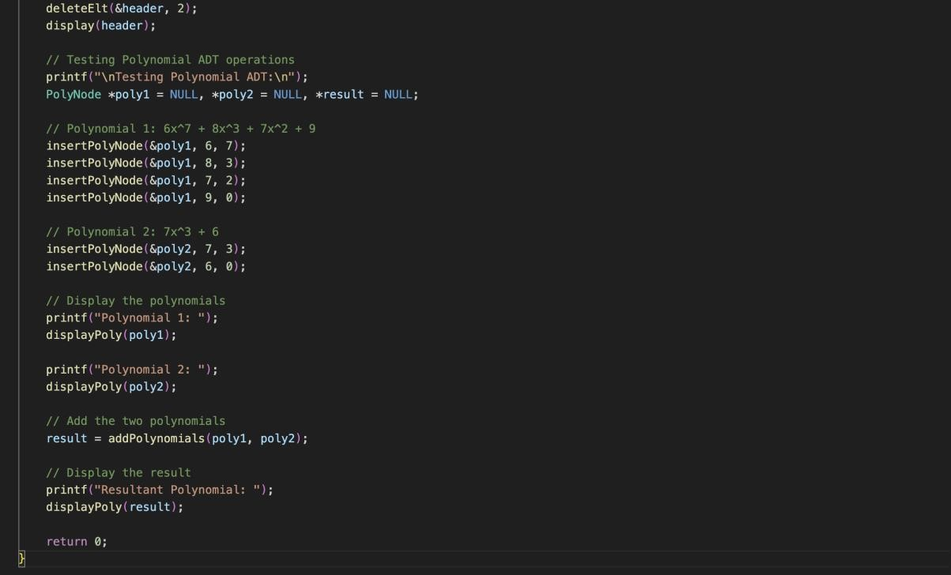

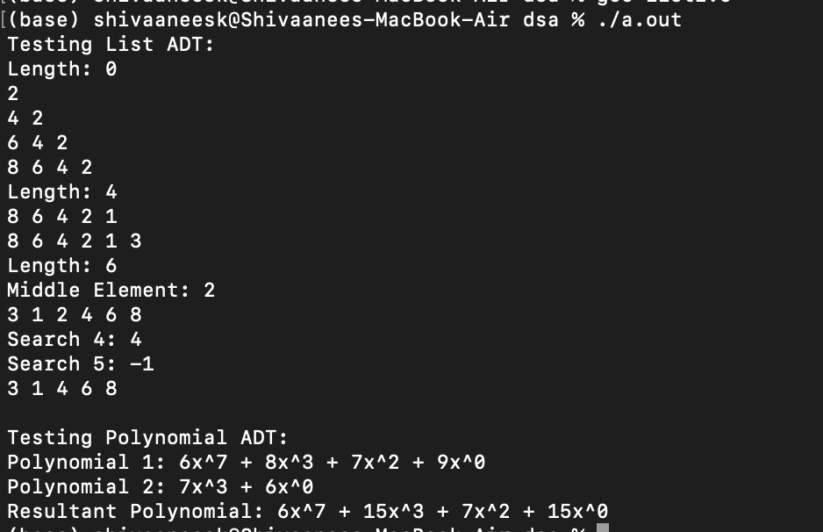

Technical Outcomes

|  |  |  |
| --- | --- | --- |
| Design | 3 | nice |
| Understanding of DS | 3 | Understood prprly |
| Use of DS | 2 | Could do better |
| Debugging | 1 | Was hard |

Best Practices

|  |  |  |
| --- | --- | --- |
| Design before coding | 3 | nice |
| Usage of Algo | 1 | Better notation |
| Multifile | 3 | did |
| Versioning | 1 | didnt |